YENEPOYA INSTITUTE OF ARTS,
SCIENCE, COMMERCE AND
MANAGEMENT

Project – High Level Design
on
Hardened Cloud Infrastructure for
Smart City Data

Student Name: Nabil
Register Number : 23BCCE122
Course : BCA in Cloud Computing ,Cyber Security &
Ethical Hacking with IBM

Industry Mentor: Mr. Shashank Guided by: Ms. Vijayalaxmi

1

Table of Contents

Sl.no | Contents | Page
1 | Introduction | 1-2
1.1 | Scope of the document
1.2 | Intended Audience
1.3 | System overview
2 | System Design | 3-9
2.1 | Application Design
2.2 | Process Flow
2.3 | Information Flow
2.4 | Components Design
2.5 | Key Design Considerations
2.6 | API Catalogue
3 | Data Design | 10-11
3.1 | Data Model
3.2 | Data Access Mechanism
3.3 | Data Retention Policies
3.4 | Data Migration
4 | Interfaces | 12 -13
5 | State and Session Management | 14
6 | Caching | 15
7 | Non-Functional Requirements | 16
7.1 | Security Aspects
7.2 | Performance Aspects
8 | References | 17

- Introduction

The Secure File Storage System is a web-based application designed to protect sensitive data using encryption techniques. In modern digital environments, especially in Smart City infrastructures, large amounts of confidential data such as citizen information, infrastructure details, and administrative records are generated and stored. This data requires strong protection to prevent unauthorized access. The main objective of this system is to provide a simple and effective solution for encrypting and decrypting files using a password-based approach.
The system enables users to upload files through a web interface, apply encryption using a secure algorithm, and download the encrypted output. Similarly, users can upload encrypted files and decrypt them by entering the correct password. The application is developed using the Flask framework in Python and uses cryptographic libraries to ensure secure encryption.

1.1 Scope of the Document
This document presents the high-level design of the Secure File Storage System. It describes the system architecture, main components, process flow, data handling, and security considerations, providing an overall understanding of how the system functions.

1.2 Intended Audience
This document is intended for developers, system designers, project evaluators, and students who want to understand the design and implementation of secure file storage systems.

1.3 System Overview
The Secure File Storage System is a client-server application where users interact through a web browser. The frontend provides a simple interface for uploading files and entering passwords, while the backend processes requests and performs encryption or decryption. The system also maintains a basic activity log to track recent operations. Overall, the system ensures ease of use while maintaining strong data security.

- System Design

The system design of the Secure File Storage System focuses on creating a structured and efficient architecture that enables secure handling of user data through encryption and decryption processes. The design follows a simple client-server model where the user interacts with the system through a web interface, and all processing is handled by a backend server. This approach ensures separation of concerns, making the system easier to understand, maintain, and extend.
The application is built using the Flask framework, which acts as the core component responsible for managing user requests, routing operations, and integrating the encryption and decryption modules. When a user uploads a file and provides a password, the request is sent to the server, where the appropriate operation is determined. Based on the request type, the system invokes either the encryption or decryption module to process the file securely.
The design also includes a structured file storage mechanism, where uploaded files, encrypted files, and decrypted outputs are stored in separate directories. This organization ensures clarity in file management and prevents data conflicts. Additionally, the system maintains a simple activity log and counters to track the number of encryption and decryption operations, which are displayed on the dashboard for user awareness.
Overall, the system design emphasizes simplicity, security, and usability. By combining a lightweight web framework with strong cryptographic techniques, the application provides an effective solution for protecting sensitive data while maintaining a user-friendly experience.
2.1 Application Design
The application is developed using a web-based architecture in which the frontend is built using HTML and CSS, and the backend is implemented using the Flask framework in Python. Users interact with the system through a browser interface, which allows them to upload files and enter passwords. These requests are sent to the Flask server, where the application processes the input and performs the required operation. The server then returns the processed file as a downloadable response. This design ensures simplicity, responsiveness, and ease of use.

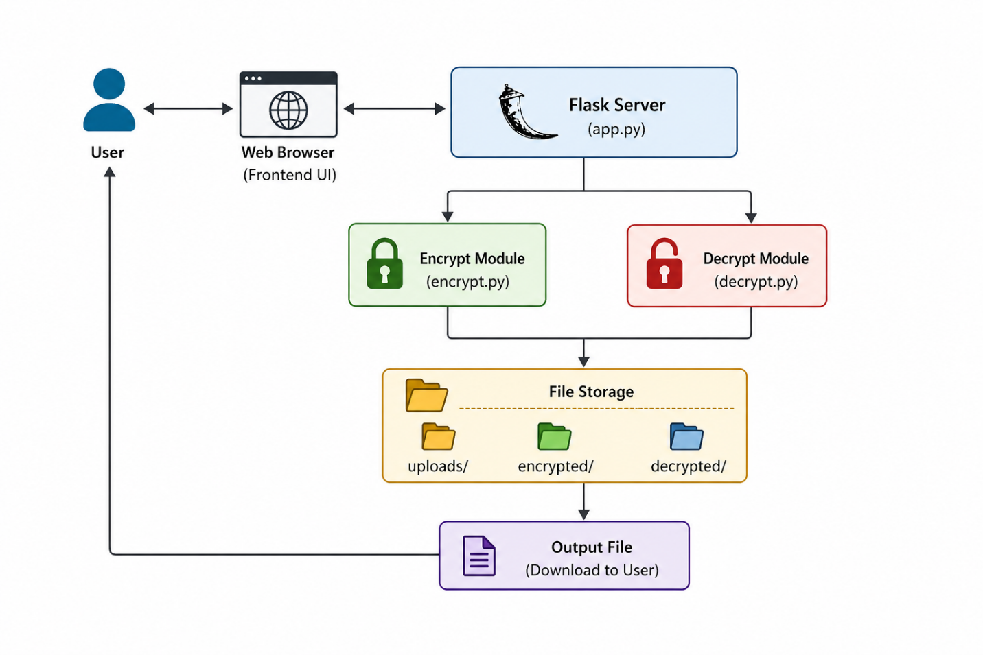

Figure 2.1: Application Design Diagram

This figure represents the overall design of the Secure File Storage System. It shows how the user interacts with the web interface, which sends requests to the Flask server. The server processes the request and uses either the encryption or decryption module to handle the file. After processing, the file is stored and returned to the user for download.

2.2 Process Flow
The system follows a clear and structured process flow for both encryption and decryption operations. When a user selects a file and enters a password for encryption, the file is uploaded to the server and temporarily stored.

The encryption module processes the file using the provided password and generates an encrypted version of the file, which is then returned to the user. Similarly, during decryption, the user uploads an encrypted file and provides the password. The system verifies the input, decrypts the file, and returns the original content. This process ensures secure handling of data at every stage.

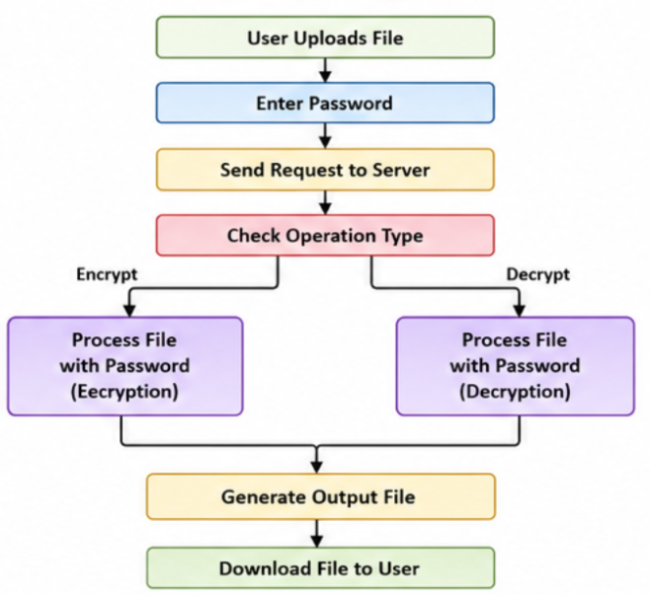

Figure 2.2: Process Flow Diagram (Encryption and Decryption)

This figure illustrates the step-by-step process followed during file encryption and decryption. It begins with the user uploading a file and entering a password. The request is then sent to the server, where the system identifies the operation type.

  - Information Flow

The flow of information begins with the user interacting with the web interface. The request is transmitted to the backend server, where it is handled by the appropriate module. Depending on the operation, the file is passed to either the encryption or decryption module. After processing, the output file is stored temporarily and sent back to the user. This structured flow ensures efficient communication between different parts of the system and maintains data integrity.

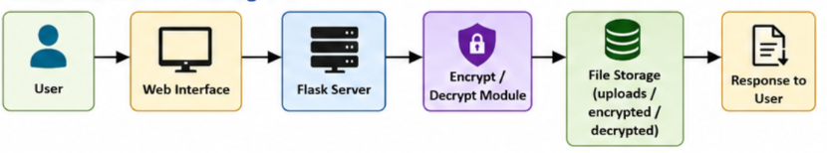

Figure 2.3: Information Flow Diagram

This figure represents how data moves within the Secure File Storage System. It shows the flow starting from the user through the web interface to the Flask server, where the request is processed. The data is then passed to the encryption or decryption module, stored temporarily, and finally returned to the user as a response. This flow ensures smooth and secure data handling throughout the system.

  - Components Design

The system is composed of multiple components that work together to provide secure file storage functionality. Each component is responsible for a specific task, ensuring modularity and ease of maintenance. The frontend handles user interaction through web pages, while the backend processes requests and manages system logic. The encryption and decryption modules perform secure cryptographic operations, and the storage component manages file organization. These components operate independently but are interconnected to ensure smooth system operation.

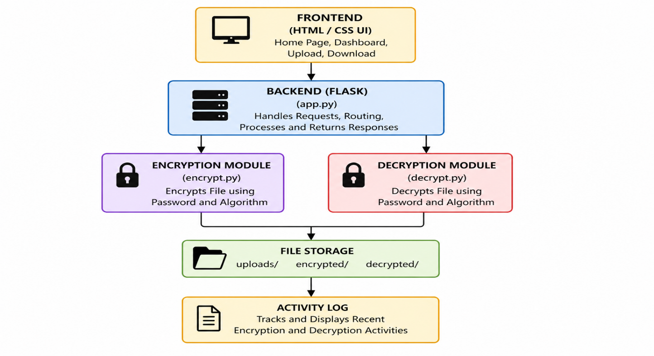

Figure 2.4: Component Design Diagram
This figure illustrates the internal components of the Secure File Storage System and their interactions. The frontend provides the user interface for uploading and downloading files, while the Flask backend handles request processing and routing. The encryption and decryption modules perform secure file operations, and the processed files are stored in organized directories. The activity log records recent operations, ensuring proper tracking of system activities.

Table 2.1: System Components Description

Component | Description
Frontend | Provides user interface for file upload, password input, and navigation
Backend (Flask) | Handles routing, request processing, and response generation
Encryption Module | Encrypts files using password-based encryption
Decryption Module | Decrypts files using the correct password
File Storage | Stores uploaded, encrypted, and decrypted files in separate folders
Activity Log | Maintains record of recent encryption and decryption operations

The system components work together to provide a smooth and secure file handling experience. The frontend allows users to interact with the system easily, while the backend processes requests and manages operations. The encryption and decryption modules ensure data security using password-based protection. File storage maintains proper organization of files, and the activity log helps in tracking recent user actions.

2.5 Key Design Considerations
The design of the system focuses on maintaining a balance between security, usability, and performance. Security is achieved by implementing strong encryption techniques and ensuring that only authorized users with the correct password can access the data. The system is designed to be simple and user-friendly, allowing users to perform operations easily without technical complexity. Performance is maintained by optimizing file handling processes and minimizing delays during encryption and decryption. Additionally

Table 2.2: Key Design Considerations

Aspect | Description
Security | Uses encryption and password protection to secure data
Simplicity | Provides easy-to-use interface for users
Performance | Ensures fast file processing and minimal delay
Scalability | Can be extended to cloud or multi-user systems
Maintainability | Modular design makes updates and changes easier

The system is designed by considering important factors such as security, usability, and performance. It ensures that user data is protected through encryption and password-based access control while maintaining a simple and intuitive interface for easy operation. The application is optimized to handle file processing efficiently, minimizing delays during encryption and decryption. In addition, the modular structure of the system improves maintainability, allowing developers to easily update or modify individual components without affecting the entire system. The design also supports scalability, making it possible to integrate advanced features such as cloud storage, user authentication, and access control in the future. Overall, the system achieves a balance between functionality, efficiency, and security, making it reliable for handling sensitive data.

  - API Catalogue

The Secure File Storage System provides a set of APIs that enable communication between the frontend interface and the backend server. These APIs handle user requests such as loading pages, uploading files, and performing encryption or decryption operations. Each API is designed to process specific tasks efficiently and return appropriate responses to the user.

Table 2.3: API Catalogue

Endpoint | Method | Input | Output | Description
/ | GET | None | Home Page | Loads the home page of the application
/dashboard | GET | None | Dashboard Page | Displays system dashboard with stats
/encrypt | POST | File, Password | Encrypted File | Encrypts uploaded file using password
/decrypt | POST | File, Password | Decrypted File | Decrypts uploaded file using password

These APIs form the core communication layer of the system, enabling smooth interaction between the user interface and backend processing. They ensure that file operations are handled securely and efficiently while providing the necessary responses to the user.

- Data Design

The data design of the Secure File Storage System focuses on secure and efficient handling of file-based data. Since the system does not use a traditional database, it relies on file storage and temporary data processing. The design ensures that sensitive data is protected during encryption and decryption while maintaining proper organization of stored files. The system separates uploaded, encrypted, and decrypted files into different directories to avoid conflicts and improve clarity.

3.1 Data Model
The system processes different types of data, including user-uploaded files, encrypted files, decrypted outputs, and user-provided passwords. Files are treated as binary data and are passed through encryption or decryption modules. The password is used only during processing and is not stored permanently, ensuring security. The system also maintains a simple activity log to track recent operations.

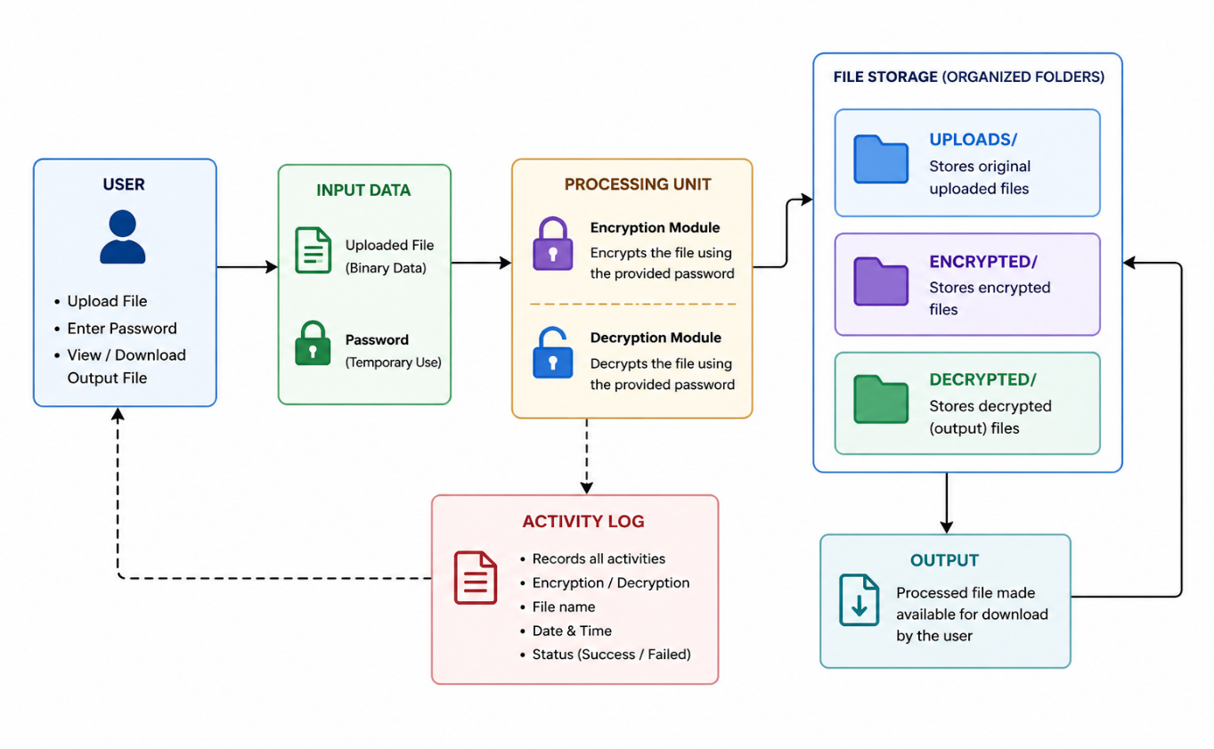
Figure 3.1: Data Model Diagram

This figure shows how data flows within the system. The user provides a file and password, which are used temporarily for processing. The system then generates and stores the output file securely.

3.2 Data Access Mechanism
The system uses a file-based access mechanism to handle data operations. Uploaded files are stored in a designated directory and accessed by the backend during processing. The encryption and decryption modules read the file data, perform the required operation, and save the output in separate folders. The processed files are then sent back to the user for download. This approach ensures controlled and secure access without the need for a database.

3.3 Data Retention Policies
The system follows a minimal data retention strategy to enhance security and privacy. Files are stored temporarily during processing and can be removed after download to prevent unnecessary storage of sensitive data. Passwords are never stored in the system, reducing the risk of data leakage. This policy ensures that only essential data is retained for a limited period.

3.4 Data Migration
Currently, the system uses local storage and does not require data migration. However, the design supports future integration with cloud storage platforms. This would allow files to be stored and accessed remotely, improving scalability and accessibility. The system can be extended to support data migration between local and cloud environments if required.

- Interfaces

The Secure File Storage System provides a web-based interface that allows users to interact with the application easily and efficiently. The interface is designed to be simple, responsive, and user-friendly so that users can perform encryption and decryption operations without any complexity. It is accessible through a web browser and does not require any additional installation.
The system consists of two main interfaces: the home page and the dashboard. The home page acts as the entry point of the application, providing an overview of the system and navigation to the dashboard. The dashboard serves as the main working interface where users can upload files, enter passwords, and perform encryption or decryption operations. It also displays useful information such as the number of processed files and recent activity logs.
The interface collects user input through file upload fields and password input fields. Once the user submits the request, the system processes it and provides the output in the form of a downloadable file. The navigation between pages is handled smoothly using links, ensuring a seamless user experience.

Interface | Description
Home Page | Displays system introduction and navigation to dashboard
Dashboard | Main interface for encryption and decryption operations
File Upload | Allows users to select and upload files
Password Input | Accepts password for secure processing
Output Download | Provides processed file for download

Figure 4.1: User Interface Flow

User
│
▼
Home Page
│
▼
Dashboard
│
┌──┴───────────────┐
▼ ▼
Encrypt Decrypt
│ │
▼ ▼
File Upload + Password
│
▼
Processing
│
▼
Download Output

The interface is designed to ensure ease of use and smooth interaction. It allows users to navigate between pages, perform operations quickly, and receive results in a clear and efficient manner.

- State and Session Management

The Secure File Storage System follows a stateless architecture, where each user request is handled independently without maintaining continuous session data on the server. This design ensures simplicity, improved performance, and enhanced security. Since the system does not require user authentication or long-term user tracking, there is no need to maintain persistent sessions.

During the interaction process, temporary state is maintained only for the duration of a request. When a user uploads a file and provides a password, the system processes the input immediately for encryption or decryption. Once the operation is completed and the output file is generated, the temporary data used during processing is discarded. This prevents unnecessary storage of sensitive information.

The system uses flash messages to provide immediate feedback to users. These messages indicate whether an operation was successful or if an error occurred, such as missing input or incorrect password. Flash messages exist only for a single request-response cycle and are cleared automatically after being displayed.
Additionally, the system avoids storing passwords or sensitive user inputs at any stage. All password handling is done temporarily in memory during processing, ensuring that no confidential data is retained. This approach significantly reduces security risks such as data leakage or unauthorized access.

Overall, the stateless and minimal session management approach makes the system lightweight, secure, and efficient. It ensures that user data is handled safely while maintaining a smooth and responsive user experience.

- Caching

The Secure File Storage System does not implement caching as a core feature due to the sensitive nature of the data being processed. While caching is typically used to enhance performance by storing frequently accessed data, applying it to encrypted or decrypted files could introduce potential security vulnerabilities. Storing such data, even temporarily, increases the risk of unauthorized access or data leakage.

In this system, every user request—whether for encryption or decryption—is processed in real time. The uploaded file is read, processed using the provided password, and the output is generated immediately. No intermediate results are stored for reuse, ensuring that sensitive data is not retained in memory or cache beyond the duration of the operation.

However, limited caching is applied at the browser level for static resources such as HTML, CSS, and user interface elements. This improves page load performance and enhances the overall user experience without compromising security, as these resources do not contain sensitive information.

By avoiding caching for file data, the system maintains strong data confidentiality and integrity. Each operation is executed independently, ensuring that no residual data from previous processes is accessible. This design choice prioritizes security while still maintaining acceptable performance, making it well-suited for applications that handle confidential information.

In future enhancements, controlled and secure caching mechanisms may be introduced for non-sensitive operations, such as metadata handling or user interface improvements. Any such implementation would ensure that cached data does not include confidential content and follows strict security policies. This would help

improve performance while still maintaining the overall security standards of the system.

7.Non-Functional Requirements

The Secure File Storage System is designed to satisfy key non-functional requirements such as security, performance, reliability, and usability. These requirements ensure that the system operates efficiently while maintaining a high level of data protection. Since the application handles sensitive information, special attention is given to maintaining confidentiality, integrity, and smooth system operation under different conditions.

7.1 Security Aspects
Security is the most important aspect of the system, as it deals with confidential files. The application uses strong password-based encryption to protect data from unauthorized access. Only users with the correct password can decrypt and access the original file, ensuring data confidentiality.
The system is designed to avoid storing sensitive information such as passwords. All passwords are used only temporarily during processing and are not saved in the system. This reduces the risk of data leakage or misuse. Additionally, files are handled securely within the server, and separate directories are maintained for uploaded, encrypted, and decrypted files to prevent data mixing and unauthorized access.The system also follows a minimal data retention approach, ensuring that temporary data is cleared after processing.

7.2 Performance Aspects
The system is optimized to deliver efficient performance during file processing operations. Encryption and decryption tasks are performed quickly to minimize user waiting time. The use of a lightweight backend framework ensures fast request handling and low system overhead.
The application processes files in real time without relying on caching for sensitive data, ensuring both security and efficiency. File handling operations are designed to be simple and direct, which helps maintain system responsiveness even when multiple requests are processed.
In addition, the interface is designed to load quickly and respond smoothly to user actions, improving the overall user experience.

8.References

The development of the Secure File Storage System is based on standard tools, frameworks, and security concepts. The backend of the system is implemented using the Flask framework, which provides lightweight and efficient handling of web requests. For encryption and decryption, the system uses the Cryptography library, which supports secure algorithms for protecting sensitive data.
Frontend development is carried out using HTML and CSS to create a responsive and user-friendly interface. Concepts related to data security, particularly encryption and protection of data at rest, are also considered during system design.

Reference Sources
- Flask Documentation: https://flask.palletsprojects.com/
- Cryptography Library Documentation: https://cryptography.io/
- Python Official Documentation: https://docs.python.org/3/
- HTML & CSS Guide (MDN Web Docs): https://developer.mozilla.org/
- NIST Guidelines on Encryption (Data Security Concepts): https://csrc.nist.gov/

